Create launch.json

Click on the Debugging icon in the View Bar on the side of VS Code. Click on the Configure gear icon on the Debug view top bar, choose Node.js as the debug environment and VS Code will generate a launch.json file under your workspace’s .vscode folder.

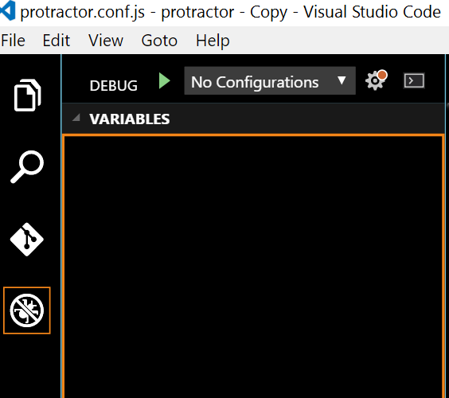

Configure protractor in launch.json

Locate the “Launch” entry in launch.json, change program and args in the following

"name": "Launch",  
"type": "node",  
"request": "launch",  
"program": "${workspaceRoot}/node_modules/protractor/bin/protractor",  
"stopOnEntry": false,  
"args": ["${workspaceRoot}/protractor.conf.js"],

Debug

Now, you can click F9 to set breakpoint, F5 to debug the script. Watch and Call stack panels are handy to inspect the running status.

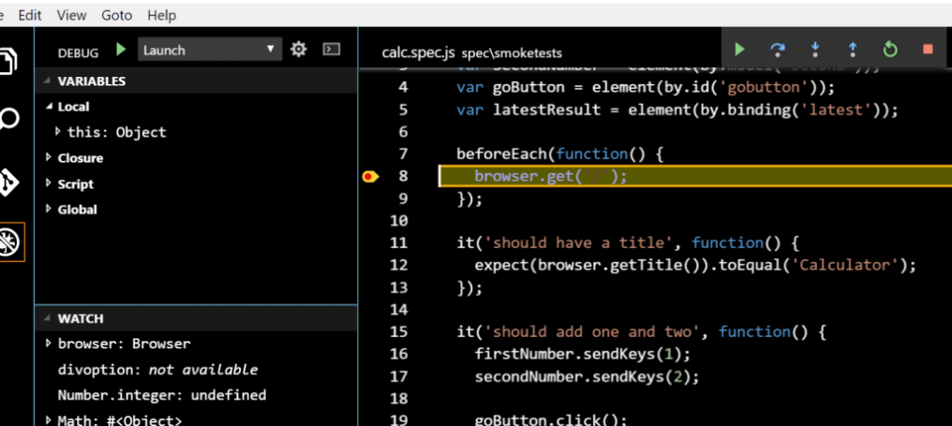

Support Suite in Configuration

Suppose you just want to debug smoke test suite while don’t want to change the Launch entry in the launch.json, you can simply copy and paste the Launch entry and rename it to SmokeTest shown below. Furthermore, add “–suite” and “smoke” to the args array entry.

"name": "SmokeTest",  
"type": "node",  
"request": "launch",  
"program": "${workspaceRoot}/node_modules/protractor/bin/protractor",  
"stopOnEntry": false,  
"args": ["${workspaceRoot}/protractor.conf.js", "--suite", "smoke"],  
"cwd": "${workspaceRoot}",  
"preLaunchTask": null,

Make sure you have chosen SmokeTest in the debug view and it will only run against smoke suite in the next debug session then.

For more information regarding to debug in visual studio code, there is a good introduction in <https://code.visualstudio.com/docs/editor/debugging>

For TypeScript execution and debugging in VS Code editor install the VS code extension Protractor Test Runner by using the command **ext install protractor-test-runner**

************